

**2016 YEAR 11 INTEGRATED SCIENCE**

**GLOBAL SYSTEMS**

**DOCUMENTARY STUDY AND DATA ANALYSIS**

**Name: _________________________________ Total: /33**

**Due Date: MONDAY 23rd May 2016**

**SECTION ONE: An inconvenient truth documentary study Total: 29 marks**

Using the information presented to you during the documentary complete the following questions.

**1. What is the most vulnerable part of the Earth and why? (2)**

_____________________________________________________________________________________________________________________________________________________________________________________________________________________________________________________________________________________________

**2. Describe how global warming occurs. (3)**

___________________________________________________________________________________________________________________________________________________________________________________________________________________________________________________________________________________________________________________________________________________________________________________________________________________________________________________________________________________________

**3. The Earth’s temperature fluctuates but what is its general trend? (1)**

**____________________________________________________________________________________________________________________________________________________________________________________________________**_________________________________________________________________________________________

**4. The Earth’s carbon dioxide levels fluctuate from summer to winter. What causes this natural fluctuation? (2)**

____________________________________________________________________________________________________________________________________________________________________________________________________________________________________________________________________________________________________________________________________________________________________________________________

**5. What can bubbles of atmosphere trapped in glacial ice tell us? (1)**

____________________________________________________________________________________________________________________________________________________________________________________________________________________________________________________________________________________________________________________________________________________________________________________________

**6. How do measurements of carbon dioxide and temperature compare? (2)**

_____________________________________________________________________________________________________________________________________________________________________________________________________________________________________________________________________________________________

**7. What is the main reason that storms are becoming stronger? (2)**

_____________________________________________________________________________________________________________________________________________________________________________________________________________________________________________________________________________________________

**8. The movie mentions “canaries in a coal mine.” What is meant by this and what are the “2 canaries” for global warming? (3)**

____________________________________________________________________________________________________________________________________________________________________________________________________________________________________________________________________________________________________________________________________________________________________________________________

**9. What are three (3) ecological problems that can result from global warming? (3)**

____________________________________________________________________________________________________________________________________________________________________________________________________________________________________________________________________________________________________________________________________________________________________________________________

**10. What are the 3 factors mentioned that lead to a collision between civilization and the Earth? (3)**

______________________________________________________________________________________________________________________________________________________________________________________________________________________________________________________________________________________________________________________________________________________________________________________________________________________________________________________________________________________________________________________________________________________________________________________________________________________________________________________________________________________________________________________________________________________________________________________________________________________________________________________________________________________________________________________________________________________________________________________

**11. What are 3 misconceptions about global warming? (3)**

_________________________________________________________________________________________________________________________________________________________________________________________________________________________________________________________________________________________________________________________________________________________________________________________________________________________________________________________________________________________________________________________________________________________________________________________________________________________________________________________________________________________

**12. What is one environmental problem that was solved by the U.S. leading the way and other nations following? (1)**

____________________________________________________________________________________________________________________________________________________________________________________________________________________________________________________________________________________________________________________________________________________________________________________________

**13. What are three (3) can you do to reduce your carbon emissions? (3)**

_________________________________________________________________________________________________________________________________________________________________________________________________________________________________________________________________________________________________________________________________________________________________________________________________________________________________________________________________________________________________________________________________________________________________________________________________________________________________________________________________________________________

**SECTION TWO: Data analysis Total 4 marks**

**Using the information provided, complete the following tasks.**

The graph below, shows the global average temperature of the Earth from 1860 to 2000, measured as 5-year averages.

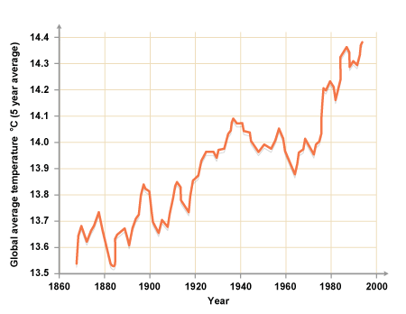

1. **From the information presented, what can you say about the temperature of the Earth? (1)**

**________________________________________________________________________________________________________________________________________________________________________________**

1. **What do you notice about the time between 1960 and 2000? (1)**

**________________________________________________________________________________________________________________________________________________________________________________**

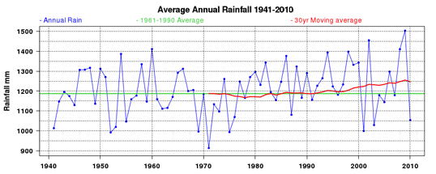The following graph depicts the average rainfall of the Earth from 1941 – 2010.

1. **What can you determine about average rainfall over time? Is there a trend in the water cycle? (2)**

**________________________________________________________________________________________________________________________________________________________________________________________________________________________________________________________________________**